Statistics Centre setup document
February 2020

Thank you for choosing our company
We appreciate your confidence in us and it is with great pleasure that we will work diligently to deliver on our promises to you.

To speed up the client setup process, please complete the document below. We try to keep our client setup document as simple as possible, but feel free to contact us if you have any problems or if you need further information. We will gladly answer any questions.

Contact
Please insert your contact details. Our client setup team will get in touch with you if further info is needed.

Click here to enter company name

Click here to enter your name

Click here to enter your email address

Click here to enter your phone number

Demo
A demo version of Betradar Statistic Centre is available HERE

Access URL
Please provide the primary URL that will be accessing the information. This is for whitelisting purposes.
Click here to enter URL

Sizing
If the desktop version of this solution will be embedded in a container with a limited size, please specify the size.
Click here to enter container size (x pixels or x percent) | ☒ No container

Styling
Please provide reference material and information on how the solution should look.

(1) Brand color - primary | Click here to enter value | (6) Background color / image (optional) | Click here to enter value
(2) Brand color - secondary | Click here to enter value | (7) Menu background color / gradient | Click here to enter value
(3) Font color | Click here to enter value | (8) Container background color | Click here to enter value
(4) Link color (optional – 3 as fallback) | Click here to enter value | (9) Table background color (optional – 2 as fallback) | Click here to enter value
(5) Link color hover (optional - 4 as fallback) | Click here to enter value
Screenshot for color reference.
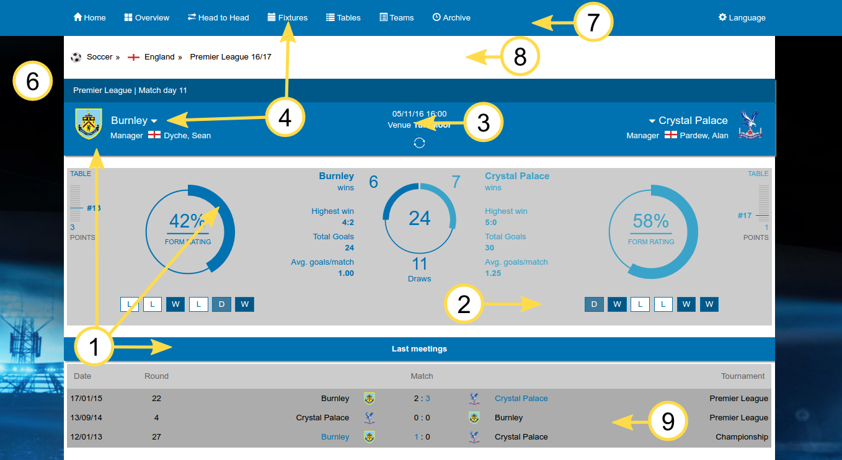

Font
Please indicate if you would like to use a custom font. Please specify font color in Styling section above.
Click here to enter font family | Click here to enter font weight
If you use a non-standard webfont (i.e. Helvetica Neue), please provide details on how to embed the font here

Banner Logo
Please attach a custom image if you wish to use your company’s logo in the banner. This banner is displayed at the top of the solution. Please provide an image in 4k resolution (or as close as possible).
☐ Logo attached | ☐ No logo required

Player names
In sports where player information is available, please choose how you would like player names to be displayed in the solution | ☐ Name and Last name (e.g Christiano Ronaldo) | ☐ Last name, first name (e.g Ronaldo, Christiano)

Display Odds
Please specify if you would like us to display the 2way odds next to results and fixtures.
☐ Display Odds | BEFORE MATCH  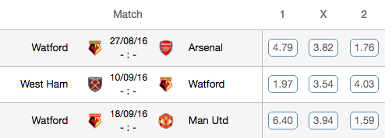  AFTER MATCH  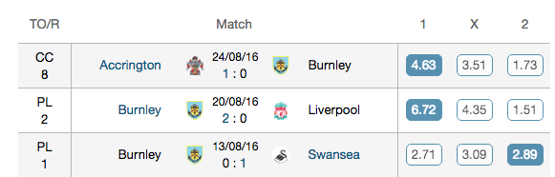
If you would like odds to take users through to a betting site, please provide us with the URL.
Alternatively, if you would like to take users (by selecting odds) to their betslip, provide us with your URL that will add selection to their bet slip.
☐ I want to enable odds to take users through to a betting site. | Bookmaker | Click here to enter your Affiliate link
☐ I want to enable users to select odds and add bet selection to their betslip. | Click here to enter url to add to the betslip

Comments
Please share any questions or additional information you have.
Click here to enter your comments

Thank You!
Thank you for completing our client setup document. We will do our best to accommodate your requests. Please make sure that all necessary files are attached before sending.

